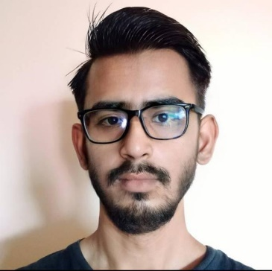
Syed Ali Naqi Hasni - Web Developer at eSpark Consulting Group
eSpark Consulting Group are really pleased to have Syed Hasni on board. He’s a key part of our Dev team and the wider eSpark Consulting Group digital marketing machine, and life would be a lot tougher if we didn’t have him and his seven years of development experience to call upon! Able to turn his hand to almost any task on the development side of digital marketing,
Syed Hasni really is one of the unsung heroes of the office… he masters the machine and turns the ideas of our creatives into an actual, functioning website, app, or custom feature. And behind all of these activities is an in-depth knowledge of platforms like WordPress, Raspberry Pi and Android, as well as the languages necessary to develop awesome solutions on those platforms.
Not one to rest on his laurels though, Syed Hasni is looking to add even more capabilities to his Digital Marketing skillset, and since coming to eSpark Consulting Group he’s really stepped up the amount of web design he does, and is expanding those horizons further by learning the art of great SEO from Dean himself.
Away from work Syed Hasni is a big cinema and comic book fan (particularly the Marvel universe). He loves bikes too, and keeping fit – which is useful as he’s also a bit of a foodie, and all that riding, jogging and walking lets him indulge his sweet tooth more often than the rest of us!
Want to get in touch with Syed Hasni or the rest of our team? Reach out to us using any of the contact details you’ll find on our ‘contact us’ page – or if you prefer, drop us a line on social media via Facebook, Twitter, or Instagram!

